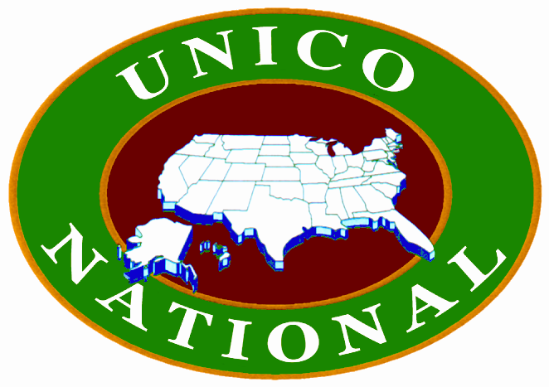

RITUAL FOR INSTALLATION OF DISTRICT GOVERNOR

Please present the District Governor(s) for installation.

My Fellow Unican(s), as member(s) of the Board of Directors for UNICO National, to which you have been elected, it shall be your duty to pay constant attention to the affairs of your District and to those of UNICO National. You are charged to exercise prudence and to use your best judgment in conducting matters, which so intimately concern the success and growth of your District and of UNICO National. You should attend all meetings. Make your part of the administration of this organization a personal duty, and by your faithful diligence, you will gain not only the approval of your fellow members, but also their gratitude. May you be faithful to your trust.

Please raise your right hand and repeat with me the following:

I (give your name) having been elected to the office of District Governor of the __________ District of UNICO National, do solemnly swear that I will faithfully and impartially perform the duties of the office to which I have been elected and will do my best to preserve, protect and defend the Constitution of the United States, the Constitution of UNICO National, By-Laws, Rules and Regulations of UNICO National, and the ___________District, as they are now in force, and which may hereafter be enacted and promulgated. So help me God.

I now declare you duly installed and qualified to take your respective offices.

CONGRATULATIONS!

