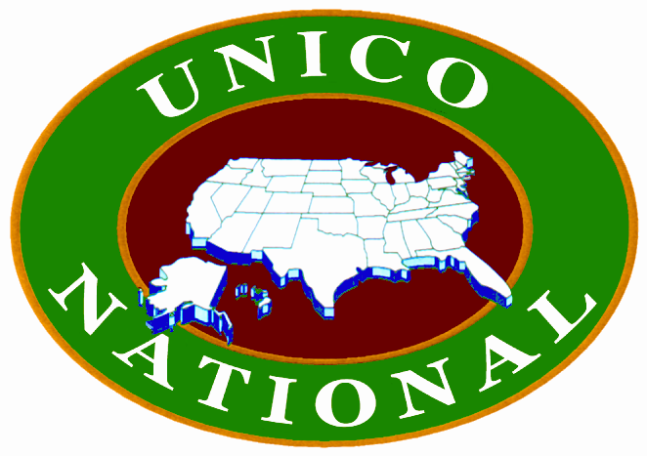

UNICO PRAYER

Bless us, Oh Lord, our Heavenly Father.
Bless this food which we are about to partake through thy grace!
Bless this meeting and the work in which we are engaged!
Bless UNICO and all those who contribute to its cause!
Make us, Oh Lord,
Strong in our Unity,
Constant in our love for our Neighbor,
Honest in our Integrity,
Unselfish in our Charity, and
Grateful for the Opportunity to serve,
We ask it in Thy Name – Amen

BENEDICTION

We give Thee thanks, Oh Lord, for these Thy gifts and this Spirit of Unity that has made this gathering pleasing to Thine eyes and all our associates. We ask that this Spirit of Unity, Neighborliness, Integrity, Charity and Opportunity, as practiced by UNICO, be preserved and may we in our endeavors always be mindful of our duties toward Thee and all our fellowmen – and keep uppermost in our hearts and minds that we are here and in our service that we be blessed with all Thy bounties. Amen

